 | Experiment Title: Design a lexical analyzer for given language and the lexical analyzer should ignore redundant spaces, tabs and new lines. It should also ignore comments. Although the syntax specification states that identifiers can be arbitrarily long, you may restrict the length to some reasonable value. Simulate the same in C language.
 | Laboratory: Compiler Design LAB
Experiment No: 1 | Department: | Semester:

PROGRAM LOGIC:
- Read the input Expression.
- Check whether input is alphabet or digits then store it as identifier.
- If the input is is operator store it as symbol.
- Check the input for keywords.

PROGRAM
#include<string.h>
#include<ctype.h>
#include<stdio.h>
int main(){
FILE *f1;
char c,str[10];
int lineno=1,num=0,i=0;
printf("\nEnter the c program\n");
f1=fopen("input.txt","w");
while((c=getchar())!=EOF)
putc(c,f1);
fclose(f1);
f1=fopen("input.txt","r");
while((c=getc(f1))!=EOF)
{
if(isdigit(c)) // TO RECOGNIZE NUMBERS
{
num=c-48;
c=getc(f1);
while(isdigit (c))
{
num=num*10+(c48);
c=getc(f1);
}
printf("%d is a number \n",num); ungetc(c,f1);
}
else if(isalpha(c)) // TO RECOGNIZE KEYWORDS AND IDENTIFIERS
{
str[i++] =c;
c=getc(f1);
while(isdigit(c)||isalpha(c)||c=='_'||c=='$')
str[i++]='\0';
if(strcmp("for",str)==0||strcmp("while",str)==0||strcmp("do",str)==0||
strcmp("int",str)==0||strcmp("float",str)==0||strcmp("char",str)==0||
strcmp("double",str)==0||strcmp("static",str)==0||
strcmp("switch",str)==0||strcmp("case",str)==0) // TYPE 32
KEYWORDS printf("%s is a keyword\n",str);
else
printf("%s is a identifier\n",str);
ungetc(c,f1);
i=0;
}
else if(c==' '||c=='\t') // TO IGNORE THE
SPACE printf("\n");
else if(c=='\n') // TO COUNT LINE
NUMBER lineno++;
else // TO FIND SPECIAL SYMBOL
printf("%c is a special symbol\n",c);
}
printf("Total no. of lines are:
%d\n",lineno); fclose(f1);
return 0;
}

OUTPUT
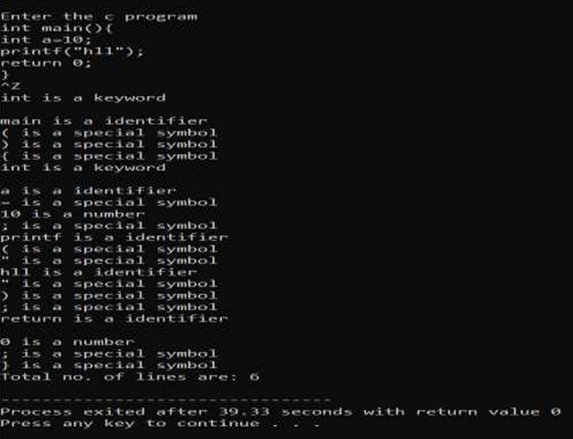

 | Experiment Title: Write a C program to identify whether a given line is a comment or not.
 | Laboratory: Compiler Design LAB
Experiment No: 2 | Department: | Semester:

PROGRAM
#include<stdio.h>
#include<conio.h>
void main() {
char com[30];
int i=2,a=0;
clrscr();
printf("\n Enter comment:");
gets(com);
if(com[0]=='/') {
if(com[1]=='/')
printf("\n It is a comment");
else if(com[1]=='*') {
for(i=2;i<=30;i++){
if(com[i]=='*'&&com[i+1]=='/'){
printf("\n It is a comment");
a=1;
break; }
else
continue; }
if(a==0)
printf("\n It is not a comment");
}
else
printf("\n It is not a comment");
}
else
printf("\n It is not a comment");
getch(); }

OUTPUT
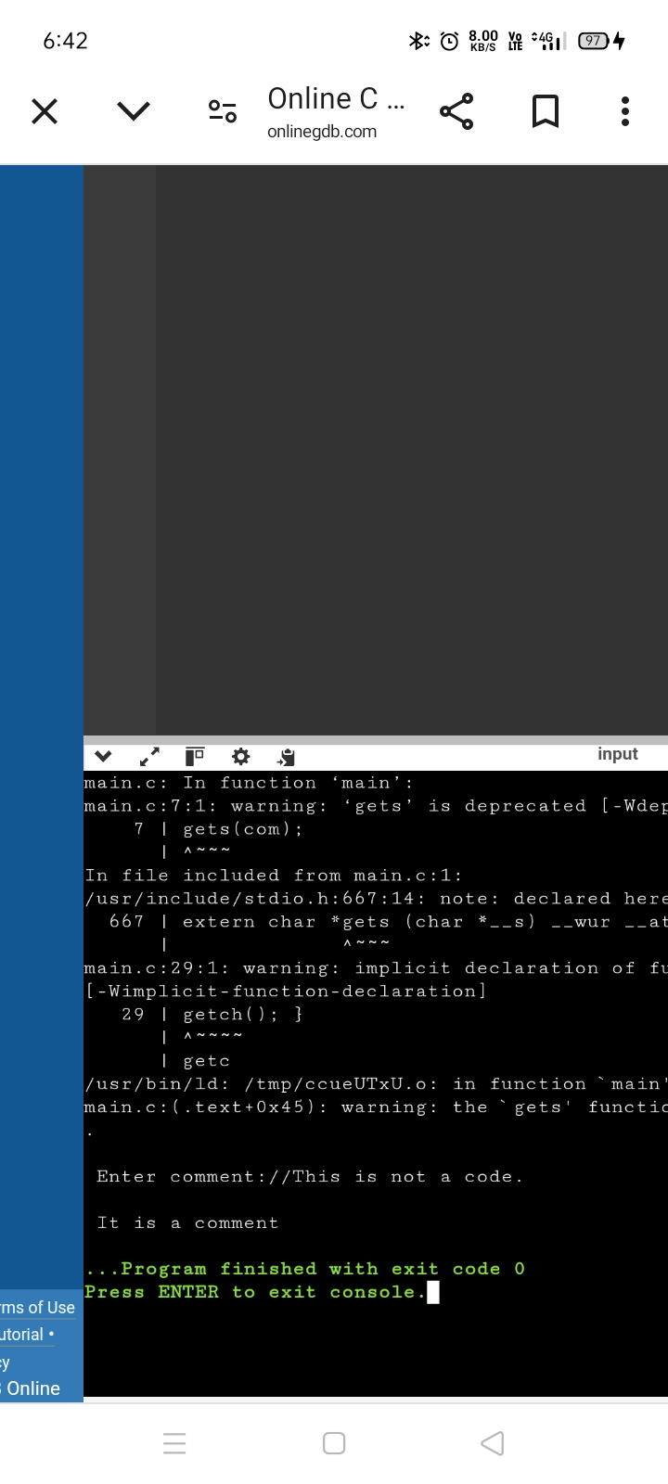

 | Experiment Title: Write a C program to recognize strings under 'a', 'a*b+', 'abb'.
 | Laboratory: Compiler Design LAB
Experiment No: 3 | Department: | Semester:

PROGRAM LOGIC:
By using transition diagram we verify input of the state.
If the state recognize the given pattern rule.
Then print string is accepted under a*/ a*b+/ abb.
Else print string not accepted.

PROGRAM

#include<stdioh>
#include<string.h>
#include<stdlib.h>
int main()
{
char s[20],c;
int state=0,i=0;
printf("\n Enter a string:");
gets(s);
while(s[i]!='\0')
{
switch(state)
{
case 0: c=s[i++];
if(c=='a')
state=1;
else if(c=='b')
state=2;
else
state=6;
break;
case 1: c=s[i++];
if(c=='a')
state=3;
else if(c=='b')
state=4;
else
break;
case 2: c=s[i++];
state=6;
if(c=='a')
state=6;
else if(c=='b')
state=2;
else
break;
state=6;
case 3: c=s[i++];
if(c=='a')
state=3;

else if(c=='b')
state=2;
else
break;
case 4: c=s[i++];
state=6;
if(c=='a')
state=6;
else if(c=='b')
state=5;
if(state==1)
printf("\n %s is accepted under rule 'a'",s);
else if((state==2)||(state==4))
printf("\n %s is accepted under rule 'a*b+'",s);
else if(state==5)
printf("\n %s is accepted under rule 'abb'",s);
return 0;
}

OUTPUT
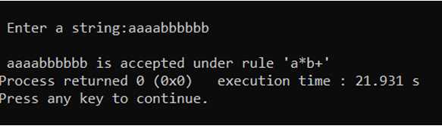

 | Experiment Title: Write a C program to test whether a given identifier is valid or not.
 | Laboratory: Compiler Design LAB
Experiment No: 4 | Department: | Semester:

PROGRAM LOGIC:
- Read the given input string.
- Check the initial character of the string is numerical or any special character except ‘_’ then print it is not a valid identifier.
- Otherwise print it as valid identifier if remaining characters of string doesn’t contains any special characters except ‘_’.

PROGRAM
#include<stdio.h>
#include<conio.h>
#include<ctype.h>
void main()
{
char a[10];
int flag, i=1;
clrscr();
printf("\n Enter an identifier:");
gets(a);
if(isalpha(a[0]))
flag=1;
else
printf("\n Not a valid identifier");
while(a[i]!='\0')
{
if(!isdigit(a[i])&&!isalpha(a[i]))

{
flag=0;
break;
}
i++;
}
if(flag==1)
printf("\n Valid identifier");
getch();
}

OUTPUT

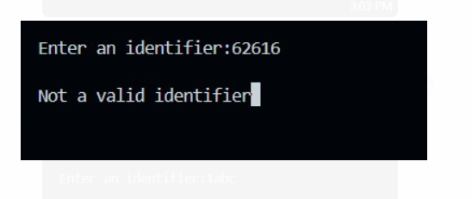

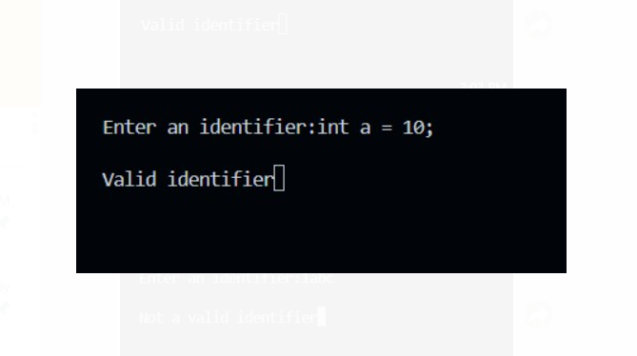

 | Experiment Title: Write a C program to simulate lexical analyzer for validating operators.
 | Laboratory: Compiler Design LAB
Experiment No: 5 | Department: | Semester:

PROGRAM LOGIC :
- Read the given input.
- If the given input matches with any operator symbol.
- Then display in terms of words of the particular symbol.
- Else print not a operator.

PROGRAM
#include<stdio.h>
#include<conio.h>
void main()
{
char s[5];
clrscr();
printf("\n Enter any operator:");
gets(s);
switch(s[0])
{
case'>': if(s[1]=='=')
printf("\n Greater than or equal");
else
printf("\n Greater than");
break;
case'<': if(s[1]=='=')
printf("\n Less than or equal");
else
printf("\nLess than");
break;
case'=': if(s[1]=='=')
printf("\nEqual to");
else
printf("\nAssignment");
break;
case'!': if(s[1]=='=')
printf("\nNot Equal");
else
printf("\n Bit Not");
break;
case'&': if(s[1]=='&')
printf("\nLogical AND");
else
printf("\n Bitwise AND");
break;
case'|': if(s[1]=='|')
printf("\nLogical OR");

else
printf("\nBitwise OR");
break;
case'+': printf("\n Addition");
break;
case'-': printf("\nSubstraction");
break;
case'*': printf("\nMultiplication");
break;
case'/': printf("\nDivision");
break;
case'%': printf("Modulus");
break;
default: printf("\n Not a operator");
}
getch();
}

OUTPUT

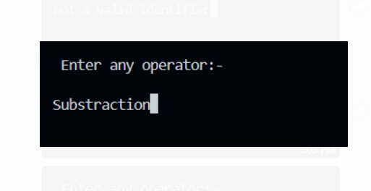

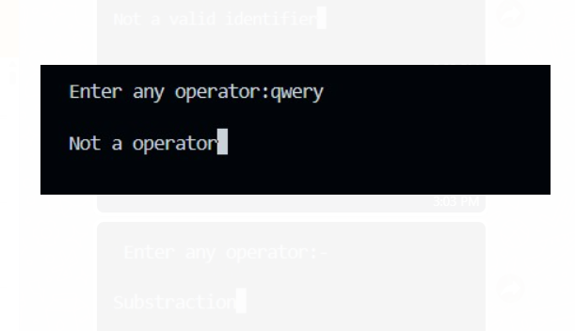

 | Experiment Title: Implement the lexical analyzer using JLex, flex or other lexical analyzer generating tools.
 | Laboratory: Compiler Design LAB
Experiment No: 6 | Department: | Semester:

PROGRAM LOGIC:
- Read the input string.
- Check whether the string is identifier/ keyword /symbol by using the rules of identifier and keywords using
- LEX Tool

PROGRAM

//Implementation of Lexical Analyzer using Lex tool
%{
int COMMENT=0;
%}
identifier [a-zA-Z][a-zA-Z0-9]*
%%
#.* {printf("\n%s is a preprocessor directive",yytext);}
int |
float |
char |
double |
while |
for |
struct |
typedef |
do |
if |
break |
continue |
void |
switch |
return |
else |
goto {printf("\n\t%s is a keyword",yytext);}
"/*" {COMMENT=1;}{printf("\n\t %s is a COMMENT",yytext);}
{identifier}\( {if(!COMMENT)printf("\nFUNCTION \n\t%s",yytext);}
\{ {if(!COMMENT)printf("\n BLOCK BEGINS");}
\} {if(!COMMENT)printf("BLOCK ENDS ");}
{identifier}(\[[0-9]*\])? {if(!COMMENT) printf("\n %s IDENTIFIER",yytext);}
\".*\" {if(!COMMENT)printf("\n\t %s is a STRING",yytext);}
[0-9]+ {if(!COMMENT) printf("\n %s is a NUMBER ",yytext);}
\)(\:)? {if(!COMMENT)printf("\n\t");ECHO;printf("\n");}
\( ECHO;
= {if(!COMMENT)printf("\n\t %s is an ASSIGNMENT OPERATOR",yytext);}
\<= |
\>= |
\< |
== |
\> {if(!COMMENT) printf("\n\t%s is a RELATIONAL OPERATOR",yytext);}
%%
int main(int argc, char **argv)
{
FILE *file;
file=fopen("var.c","r");
if(!file)
{
printf("could not open the file");
exit(0);
}
yyin=file;
yylex();
printf("\n");
return(0);
}
int yywrap()
{
return(1);
}
INPUT:
//var.c
#include<stdio.h>
#include<conio.h>
void main()
{
int a,b,c;
a=1;
b=2;
c=a+b;
printf("Sum:%d",c);
}

OUTPUT

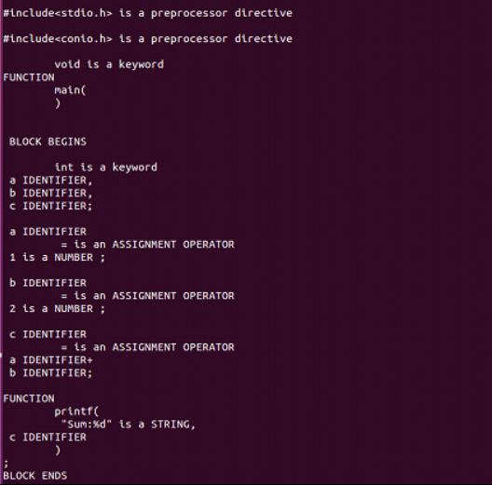

 | Experiment Title: Write a C program for implementing the functionalities of predictive parser for the mini language specified in Note 1.
 | Laboratory: Compiler Design LAB
Experiment No: 7 | Department: | Semester:

PROGRAM LOGIC:
- Read the input string.
- By using the FIRST AND FOLLOW values.
- Verify the FIRST of non terminal and insert the production in the FIRST value
- If we have any @ terms in FIRST then insert the productions in FOLLOW values
- Constructing the predictive parser table

PROGRAM

#include <stdio.h>
#include <conio.h>
#include <string.h>
char prol[7][10] = {"S", "A", "A", "B", "B", "C", "C"};
char pror[7][10] = {"A", "Bb", "Cd", "aB", "@", "Cc", "@"};
char prod[7][10] = {"S->A", "A->Bb", "A->Cd", "B->aB", "B->@", "C->Cc", "C->@"};
char first[7][10] = {"abcd", "ab", "cd", "a@", "@", "c@", "@"};
char follow[7][10] = {"$", "$", "$", "a$", "b$", "c$", "d$"};
char table[5][6][10];
numr(char c)
{
switch (c)
{
case 'S':
return 0;
case 'A':
return 1;
case 'B':
return 2;
case 'C':
return 3;
case 'a':
return 0;
case 'b':
return 1;
case 'c':
return 2;
case 'd':
return 3;
case '$':
return 4;
}
return (2);
}
void main()
{
int i, j, k;
// clrscr();
for (i = 0; i < 5; i++)
for (j = 0; j < 6; j++)
strcpy(table[i][j], " ");
printf("\nThe following is the predictive parsing table for the following grammar:\n");
for (i = 0; i < 7; i++)
printf("%s\n", prod[i]);
printf("\nPredictive parsing table is\n");
fflush(stdin);
for (i = 0; i < 7; i++)
{
k = strlen(first[i]);
for (j = 0; j < 10; j++)
if (first[i][j] != '@')
strcpy(table[numr(prol[i][0]) + 1][numr(first[i][j]) + 1], prod[i]);
}
for (i = 0; i < 7; i++)
{
if (strlen(pror[i]) == 1)
{
if (pror[i][0] == '@')
{

k = strlen(follow[i]);
for (j = 0; j < k; j++)
strcpy(table[numr(prol[i][0]) + 1][numr(follow[i][j]) + 1], prod[i]);

}
}
}
strcpy(table[0][0], " ");
strcpy(table[0][1], "a");
strcpy(table[0][2], "b");
strcpy(table[0][3], "c");
strcpy(table[0][4], "d");
strcpy(table[0][5], "$");
strcpy(table[1][0], "S");
strcpy(table[2][0], "A");
strcpy(table[3][0], "B");
strcpy(table[4][0], "C");
printf("\n--------------------------------------------------------\n");
for (i = 0; i < 5; i++)
for (j = 0; j < 6; j++)
{
printf("%-10s", table[i][j]);
if (j == 5)
printf("\n--------------------------------------------------------\n");
}
getch();
}

OUTPUT

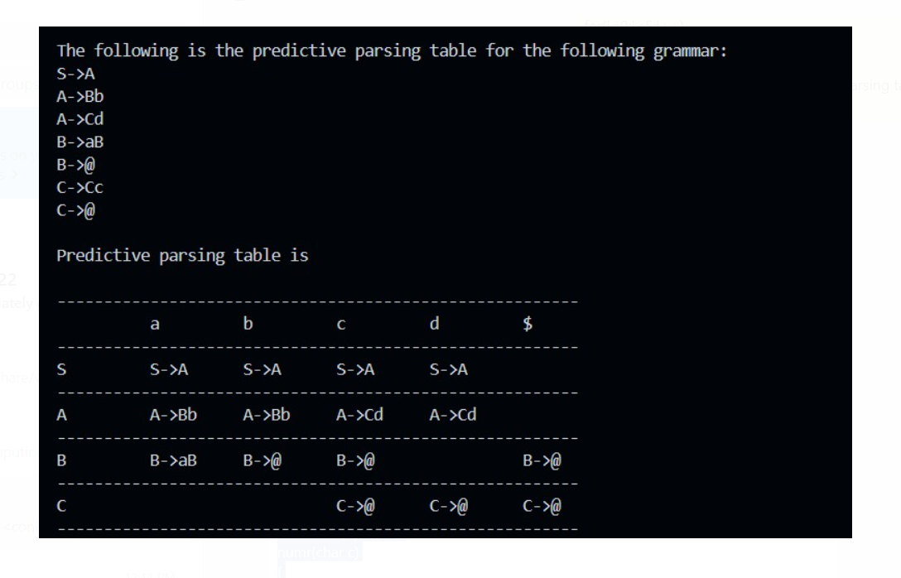

 | Experiment Title: a) Write a C program for constructing of LL (1) parsing. b) Write a C program for constructing recursive descent parsing.
 | Laboratory: Compiler Design LAB
Experiment No: 8 | Department: | Semester:

a) Write a C program for constructing of LL (1) parsing.
PROGRAM LOGIC:
- Read the input string.
- By using the FIRST AND FOLLOW values.
- Verify the FIRST of non terminal and insert the production in the FIRST value
- If we have any @ terms in FIRST then insert the productions in FOLLOW values
- Constructing the predictive parser table

PROGRAM
#include<conio.h>
#include<string.h>
char s[20],stack[20];
void main()
{
char m[5][6][3]={"tb"," "," ","tb"," "," "," ","+tb"," "," ","n","n","fc"," "," ","fc"," "," "," ","n","*fc"," a","n","n","i"," "," ","(e)"," "," "};

int size[5][6]={2,0,0,2,0,0,0,3,0,0,1,1,2,0,0,2,0,0,0,1,3,0,1,1,1,0,0,3,0,0};
int i,j,k,n,str1,str2;
// clrscr();
printf("\n Enter the input string: ");
scanf("%s",s);
strcat(s,"$");
n=strlen(s);
stack[0]='$';
stack[1]='e';
i=1;
j=0;
printf("\nStack Input\n");
printf("__________________\n");
while((stack[i]!='$')&&(s[j]!='$'))
{
if(stack[i]==s[j])
{
i--;
j++;
}
switch(stack[i])
{
case 'e': str1=0;
break;
case 'b': str1=1;
break;
case 't': str1=2;
break;
case 'c': str1=3;
break;
case 'f': str1=4;
break;
}
switch(s[j])
{
case 'i': str2=0;
break;
case '+': str2=1;
break;
case '*': str2=2;
break;
case '(': str2=3;
break;
case ')': str2=4;
break;
case '$': str2=5;
break;

}
if(m[str1][str2][0]=='\0')
{
printf("\nERROR");
exit(0);
}
else if(m[str1][str2][0]=='n')
i--;
else if(m[str1][str2][0]=='i')

stack[i]='i';
else
{
for(k=size[str1][str2]-1;k>=0;k--)
{
stack[i]=m[str1][str2][k];
i++;
}
i--;
}
for(k=0;k<=i;k++)
printf(" %c",stack[k]);
printf(" ");
for(k=j;k<=n;k++)
printf("%c",s[k]);
printf(" \n ");
}
printf("\n SUCCESS");
getch(); }

OUTPUT

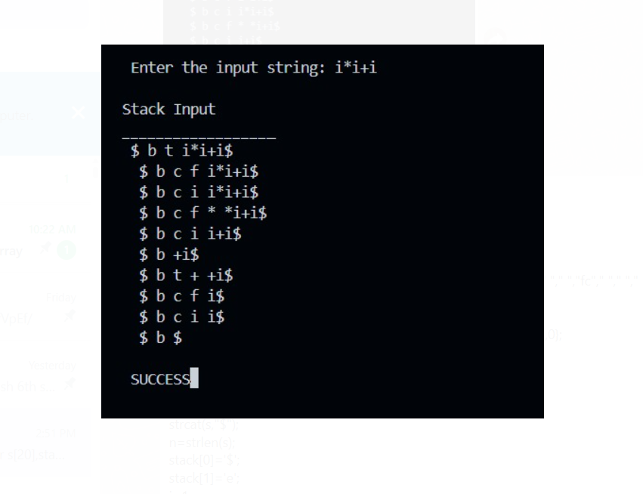

b) Write a C program for constructing recursive descent parsing.

PROGRAM LOGIC:
- Read the input string.
- Write procedures for the non terminals
- Verify the next token equals to non terminals if it satisfies match the non terminal.
- If the input string does not match print error.

PROGRAM
#include <stdio.h>
#include <conio.h>
#include <string.h>
char input[100];
int i, l;
void main()
{
// clrscr();
printf("\nRecursive descent parsing for the following grammar\n");
printf("\nE->TE'\nE'->+TE'/@\nT->FT'\nT'->*FT'/@\nF->(E)/ID\n");
printf("\nEnter the string to be checked:");
gets(input);
if (E())
{
if (input[i + 1] == '\0')
printf("\nString is accepted");
else
printf("\nString is not accepted");
}
else
printf("\nString not accepted");

getch();
}
E()
{
if (T())
{
if (EP())
return (1);
else
return (0);
}
else
return (0);
}
EP()
{
if (input[i] == '+')
{
i++;
if (T())
{
if (EP())
return (1);
else
return (0);
}
else
return (0);
}
else
return (1);
}
T()
{
if (F())
{
if (TP())
return (1);
else
return (0);
}
else

return (0);
}
TP()
{
if (input[i] == '*')
{
i++;
if (F())
{
if (TP())
return (1);
else
return (0);
}
else
return (0);
}
else
return (1);
}
F()
{
if (input[i] == '(')
{
i++;
if (E())
{
if (input[i] == ')')
{
i++;
return (1);
}
else
return (0);
}
else
return (0);
}
else if (input[i] >= 'a' && input[i] <= 'z' || input[i] >= 'A' && input[i] <= 'Z')

{
i++;
return (1);
}
else
return (0);
}

OUTPUT

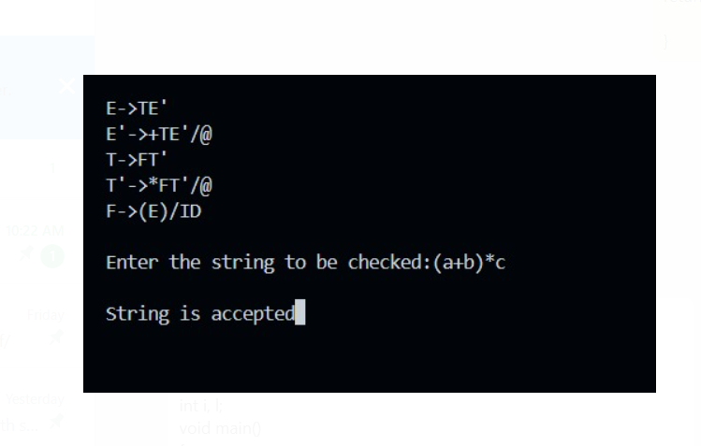

 | Experiment Title: Write a C program to implement LALR parsing.
 | Laboratory: Compiler Design LAB
Experiment No: 9 | Department: | Semester:

PROGRAM LOGIC:
- Read the input string.
- Push the input symbol with its state symbols in to the stack by referring lookaheads
- We perform shift and reduce actions to parse the grammar.
- Parsing is completed when we reach $ symbol.

PROGRAM
#include <stdio.h>
#include <conio.h>
#include <stdlib.h>
#include <string.h>
void push(char *, int *, char);
char stacktop(char *);
void isproduct(char, char);
int ister(char);
int isnter(char);
int isstate(char);
void error();
void isreduce(char, char);
char pop(char *, int *);
void printt(char *, int *, char[], int);
void rep(char[], int);
struct action
{
char row[6][5];
};
const struct action A[12] = {

{"sf", "emp", "emp", "se", "emp", "emp"},
{"emp", "sg", "emp", "emp", "emp", "acc"},
{"emp", "rc", "sh", "emp", "rc", "rc"},
{"emp", "re", "re", "emp", "re", "re"},
{"sf", "emp", "emp", "se", "emp", "emp"},
{"emp", "rg", "rg", "emp", "rg", "rg"},
{"sf", "emp", "emp", "se", "emp", "emp"},
{"sf", "emp", "emp", "se", "emp", "emp"},
{"emp", "sg", "emp", "emp", "sl", "emp"},
{"emp", "rb", "sh", "emp", "rb", "rb"},
{"emp", "rb", "rd", "emp", "rd", "rd"},
{"emp", "rf", "rf", "emp", "rf", "rf"}};
struct gotol
{
char r[3][4];
};
const struct gotol G[12] = {

{"b", "c", "d"},
{"emp", "emp", "emp"},
{"emp", "emp", "emp"},
{"emp", "emp", "emp"},
{"i", "c", "d"},
{"emp", "emp", "emp"},
{"emp", "j", "d"},
{"emp", "emp", "k"},
{"emp", "emp", "emp"},
{"emp", "emp", "emp"},
};
char ter[6] = {'i', '+', '*', ')', '(', '$'};
char nter[3] = {'E', 'T', 'F'};
char states[12] = {'a', 'b', 'c', 'd', 'e', 'f', 'g', 'h', 'm', 'j', 'k', 'l'};
char stack[100];
int top = -1;
char temp[10];
struct grammar
{
char left;
char right[5];
};
const struct grammar rl[6] = {
{'E', "e+T"},
{'E', "T"},
{'T', "T*F"},
{'T', "F"},
{'F', "(E)"},
{'F', "i"},
};
void main()
{
char inp[80], x, p, dl[80], y, bl = 'a';
int i = 0, j, k, l, n, m, c, len;
// clrscr();
printf(" Enter the input :");
scanf("%s", inp);
len = strlen(inp);
inp[len] = '$';
inp[len + 1] = '\0';
push(stack, &top, bl);
printf("\n stack \t\t\t input");
printt(stack, &top, inp, i);
do
{
x = inp[i];
p = stacktop(stack);
isproduct(x, p);
if (strcmp(temp, "emp") == 0)
error();
if (strcmp(temp, "acc") == 0)
break;
else
{
if (temp[0] == 's')
{
push(stack, &top, inp[i]);
push(stack, &top, temp[1]);
i++;
}
else
{
if (temp[0] == 'r')
{
j = isstate(temp[1]);
strcpy(temp, rl[j - 2].right);
dl[0] = rl[j - 2].left;
dl[1] = '\0';
n = strlen(temp);
for (k = 0; k < 2 * n; k++)
pop(stack, &top);
for (m = 0; dl[m] != '\0'; m++)
push(stack, &top, dl[m]);
l = top;
y = stack[l - 1];
isreduce(y, dl[0]);
for (m = 0; temp[m] != '\0'; m++)
push(stack, &top, temp[m]);
}
}
}
printt(stack, &top, inp, i);
} while (inp[i] != '\0');
if (strcmp(temp, "acc") == 0)
printf(" \n accept the input ");
else
printf(" \n do not accept the input ");
getch();
}
void push(char *s, int *sp, char item)
{
if (*sp == 100)
printf(" stack is full ");
else
{
*sp = *sp + 1;

s[*sp] = item;
}
}
char stacktop(char *s)
{
char i;
i = s[top];
return i;
}
void isproduct(char x, char p)
{
int k, l;
k = ister(x);
l = isstate(p);
strcpy(temp, A[l - 1].row[k - 1]);
}
int ister(char x)
{
int i;
for (i = 0; i < 6; i++)
if (x == ter[i])
return i + 1;

return 0;
}
int isnter(char x)
{
int i;
for (i = 0; i < 3; i++)
if (x == nter[i])
return i + 1;

return 0;
}
int isstate(char p)
{
int i;
for (i = 0; i < 12; i++)
if (p == states[i])

return i + 1;
return 0;
}
void error()
{
printf(" error in the input ");
exit(0);
}
void isreduce(char x, char p)
{
int k, l;
k = isstate(x);
l = isnter(p);
strcpy(temp, G[k - 1].r[l - 1]);
}
char pop(char *s, int *sp)
{
char item;
if (*sp == -1)
printf(" stack is empty ");
else
{
item = s[*sp];
*sp = *sp - 1;
}
return item;
}
void printt(char *t, int *p, char inp[], int i)
{
int r;
printf("\n");
for (r = 0; r <= *p; r++)
rep(t, r);
printf("\t\t\t");
for (r = i; inp[r] != '\0'; r++)

printf("%c", inp[r]);
}
void rep(char t[], int r)
{
char c;
c = t[r];
switch (c)
{
case 'a':
printf("0");
break;
case 'b':
printf("1");
break;
case 'c':
printf("2");
break;
case 'd':
printf("3");
break;
case 'e':
printf("4");
break;
case 'f':
printf("5");
break;
case 'g':
printf("6");
break;
case 'h':
printf("7");
break;
case 'm':
printf("8");
break;
case 'j':
printf("9");
break;
case 'k':
printf("10");
break;
case 'l':
printf("11");
break;
default:
printf("%c", t[r]);
break;
}
}

OUTPUT

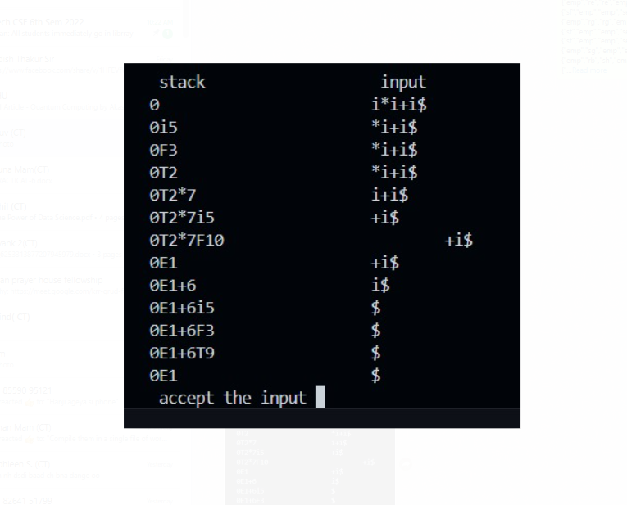

 | Experiment Title: a) Write a C program to implement operator precedence parsing. b) Write a C program to implement Program semantic rules to calculate the expression that takes an expression with digits, + and * and computes the value.
 | Laboratory: Compiler Design LAB
Experiment No: 10 | Department: | Semester:

- Write a C program to implement operator precedence parsing.
PROGRAM LOGIC:
- Read the arithmetic input string.
- Verify the precedence between terminals and symbols
- Find the handle enclosed in < . > and reduce it to production symbol.
- Repeat the process till we reach the start node.

PROGRAM
#include<stdio.h>
#include<string.h>

char *input;
int i=0;
char lasthandle[6],stack[50],handles[][5]={")E(","E*E","E+E","i","E^E"};
//(E) becomes )E( when pushed to stack

int top=0,l;
char prec[9][9]={

/*input*/

/*stack + - * / ^ i ( ) $ */

/* + */ '>', '>','<','<','<','<','<','>','>',

/* - */ '>', '>','<','<','<','<','<','>','>',

/* * */ '>', '>','>','>','<','<','<','>','>',

/* / */ '>', '>','>','>','<','<','<','>','>',

/* ^ */ '>', '>','>','>','<','<','<','>','>',

/* i */ '>', '>','>','>','>','e','e','>','>',

/* ( */ '<', '<','<','<','<','<','<','>','e',

/* ) */ '>', '>','>','>','>','e','e','>','>',

/* $ */ '<', '<','<','<','<','<','<','<','>',

};

int getindex(char c)
{
switch(c)
{
case '+':return 0;
case '-':return 1;
case '*':return 2;
case '/':return 3;
case '^':return 4;
case 'i':return 5;
case '(':return 6;
case ')':return 7;
case '$':return 8;
}
}

int shift()
{
stack[++top]=*(input+i++);
stack[top+1]='\0';
}

int reduce()
{
int i,len,found,t;
for(i=0;i<5;i++)//selecting handles
{
len=strlen(handles[i]);
if(stack[top]==handles[i][0]&&top+1>=len)
{
found=1;
for(t=0;t<len;t++)
{
if(stack[top-t]!=handles[i][t])
{
found=0;
break;
}
}
if(found==1)
{
stack[top-t+1]='E';
top=top-t+1;
strcpy(lasthandle,handles[i]);
stack[top+1]='\0';
return 1;//successful reduction
}
}
}
return 0;
}

void dispstack()
{
int j;
for(j=0;j<=top;j++)
printf("%c",stack[j]);
}

void dispinput()
{
int j;
for(j=i;j<l;j++)
printf("%c",*(input+j));
}

void main()
{
int j;

input=(char*)malloc(50*sizeof(char));
printf("\nEnter the string\n");
scanf("%s",input);
input=strcat(input,"$");
l=strlen(input);
strcpy(stack,"$");
printf("\nSTACK\tINPUT\tACTION");
while(i<=l)
{
shift();
printf("\n");
dispstack();
printf("\t");
dispinput();
printf("\tShift");
if(prec[getindex(stack[top])][getindex(input[i])]=='>')
{
while(reduce())
{
printf("\n");
dispstack();
printf("\t");
dispinput();
printf("\tReduced: E->%s",lasthandle);
}
}
}
if(strcmp(stack,"$E$")==0)
printf("\nAccepted;");
else
printf("\nNot Accepted;");
}
OUTPUT
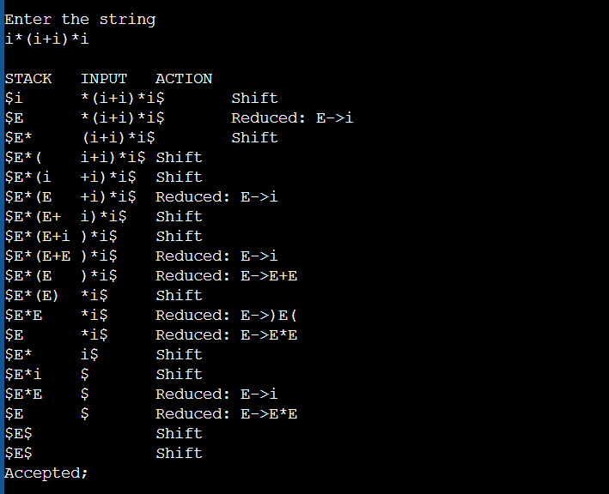
b) Write a C program to implement Program semantic rules to calculate the expression that takes an expression with digits, + and * and computes the value.
PROGRAM LOGIC:
- Reading an input file
- Calculate the sum or multiplication of given expression.
- Using expression rule print the result of the given values.

PROGRAM

%{

#include<stdio.h>

#include "y.tab.h"

extern int yylval;

%}

%%

[0-9]+ {

yylval=atoi(yytext);

return NUMBER;

}

[\t] ;

[\n] return 0;

. return yytext[0];

%%

int yywrap()

{

return 1;

}

YACC PART:

%{

#include<stdio.h>

int flag=0;

%}

%token NUMBER

%left '+' '-'

%left '*' '/' '%'

%left '(' ')'

%%

ArithmeticExpression: E{

printf("\nResult=%d\n",$$);

return 0;

};

E:E'+'E {$$=$1+$3;}

|E'-'E {$$=$1-$3;}

|E'*'E {$$=$1*$3;}

|E'/'E {$$=$1/$3;}

|E'%'E {$$=$1%$3;}

|'('E')' {$$=$2;}

| NUMBER {$$=$1;}

;

%%

void main()

{

printf("\nEnter Any Arithmetic Expression which can have operations Addition, Subtraction, Multiplication, Divison, Modulus and Round brackets:\n");

yyparse();

if(flag==0)

printf("\nEntered arithmetic expression is Valid\n\n");

}

void yyerror()

{

printf("\nEntered arithmetic expression is Invalid\n\n");

flag=1;

}

OUTPUT
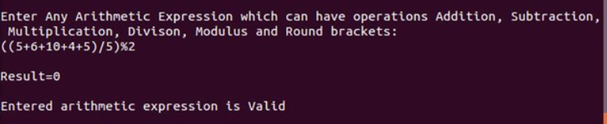
 | Experiment Title: Convert the BNF rules into YACC form and write code to generate abstract syntax tree for the mini language specified in Note 1.
 | Laboratory: Compiler Design LAB
Experiment No: 11 | Department: | Semester:

PROGRAM LOGIC:
- Reading an input file line by line.
- Convert it in to abstract syntax tree using three address code.
- Represent three address code in the form of quadruple tabular form.

PROGRAM
//Convert the BNF rules into YACC form and

//write code to generate Abstract Syntax Tree

LEX PART:

%{

#include"y.tab.h"

#include<stdio.h>

#include<string.h>

int LineNo=1;

%}

identifier [a-zA-Z][_a-zA-Z0-9]*

number [0-9]+|([0-9]*\.[0-9]+)

%%

main\(\) return MAIN;

if return IF;

else return ELSE;

while return WHILE;

int |

char |

float return TYPE;

{identifier} {strcpy(yylval.var,yytext);

return VAR;}

{number} {strcpy(yylval.var,yytext);

return NUM;}

\< |

\> |

\>= |

\<= |

== {strcpy(yylval.var,yytext);

return RELOP;}

[ \t] ;

\n LineNo++;

. return yytext[0];

%%

YACC PART:

%{

#include<string.h>

#include<stdio.h>

struct quad

{

char op[5];

char arg1[10];

char arg2[10];

char result[10];

}QUAD[30];

struct stack

{

int items[100];

int top;

}stk;

int Index=0,tIndex=0,StNo,Ind,tInd;

extern int LineNo;

%}

%union

{

char var[10];

}

%token <var> NUM VAR RELOP

%token MAIN IF ELSE WHILE TYPE

%type <var> EXPR ASSIGNMENT CONDITION IFST ELSEST WHILELOOP

%left '-' '+'

%left '*' '/'

%%

PROGRAM : MAIN BLOCK

;

BLOCK: '{' CODE '}'

;

CODE: BLOCK

| STATEMENT CODE

| STATEMENT

;

STATEMENT: DESCT ';'

| ASSIGNMENT ';'

| CONDST

| WHILEST

;

DESCT: TYPE VARLIST

;

VARLIST: VAR ',' VARLIST

| VAR

;

ASSIGNMENT: VAR '=' EXPR{

strcpy(QUAD[Index].op,"=");

strcpy(QUAD[Index].arg1,$3);

strcpy(QUAD[Index].arg2,"");

strcpy(QUAD[Index].result,$1);

strcpy($$,QUAD[Index++].result);

}

;

EXPR: EXPR '+' EXPR {AddQuadruple("+",$1,$3,$$);}

| EXPR '-' EXPR {AddQuadruple("-",$1,$3,$$);}

| EXPR '*' EXPR {AddQuadruple("*",$1,$3,$$);}

| EXPR '/' EXPR {AddQuadruple("/",$1,$3,$$);}
| '-' EXPR {AddQuadruple("UMIN",$2,"",$$);}

| '(' EXPR ')' {strcpy($$,$2);}

| VAR

| NUM

;

CONDST: IFST{

Ind=pop();

sprintf(QUAD[Ind].result,"%d",Index);

Ind=pop();

sprintf(QUAD[Ind].result,"%d",Index);

}

| IFST ELSEST

;

IFST: IF '(' CONDITION ')' {

strcpy(QUAD[Index].op,"==");

strcpy(QUAD[Index].arg1,$3);

strcpy(QUAD[Index].arg2,"FALSE");

strcpy(QUAD[Index].result,"-1");

push(Index);

Index++;

}

BLOCK { strcpy(QUAD[Index].op,"GOTO"); strcpy(QUAD[Index].arg1,"");

strcpy(QUAD[Index].arg2,"");

strcpy(QUAD[Index].result,"-1");

push(Index);

Index++;

};

ELSEST: ELSE{

tInd=pop();

Ind=pop();

push(tInd);

sprintf(QUAD[Ind].result,"%d",Index);

}

BLOCK{

Ind=pop();

sprintf(QUAD[Ind].result,"%d",Index);

};

CONDITION: VAR RELOP VAR {AddQuadruple($2,$1,$3,$$);

StNo=Index-1;

}

| VAR

| NUM

;

WHILEST: WHILELOOP{

Ind=pop();

sprintf(QUAD[Ind].result,"%d",StNo);

Ind=pop();

sprintf(QUAD[Ind].result,"%d",Index);

}

;

WHILELOOP: WHILE'('CONDITION ')' {
strcpy(QUAD[Index].op,"==");

strcpy(QUAD[Index].arg1,$3);

strcpy(QUAD[Index].arg2,"FALSE");

strcpy(QUAD[Index].result,"-1");

push(Index);

Index++;

}

BLOCK {

strcpy(QUAD[Index].op,"GOTO");

strcpy(QUAD[Index].arg1,"");

strcpy(QUAD[Index].arg2,"");

strcpy(QUAD[Index].result,"-1");

push(Index);

Index++;

}

;

%%

extern FILE *yyin;

int main(int argc,char *argv[])

{

FILE *fp;

int i;

if(argc>1)

{

fp=fopen(argv[1],"r");

if(!fp)

{

printf("\n File not found");

exit(0);

}

yyin=fp;

}

yyparse();

printf("\n\n\t\t ----------------------------""\n\t\t Pos Operator \tArg1 \tArg2 \tResult" "\n\t\t--------------------");

for(i=0;i<Index;i++)

{

printf("\n\t\t %d\t %s\t %s\t %s\t%s",i,QUAD[i].op,QUAD[i].arg1,QUAD[i].arg2,QUAD[i].result);

}

printf("\n\t\t -----------------------");

printf("\n\n"); return 0; }

void push(int data)

{ stk.top++;

if(stk.top==100)

{

printf("\n Stack overflow\n");

exit(0);

}

stk.items[stk.top]=data;

}

int pop()

{

int data;

if(stk.top==-1)

{

printf("\n Stack underflow\n");

exit(0);

}

data=stk.items[stk.top--];

return data;

}

void AddQuadruple(char op[5],char arg1[10],char arg2[10],char result[10])

{

strcpy(QUAD[Index].op,op);

strcpy(QUAD[Index].arg1,arg1);

strcpy(QUAD[Index].arg2,arg2);

sprintf(QUAD[Index].result,"t%d",tIndex++);

strcpy(result,QUAD[Index++].result);

}

yyerror()

{

printf("\n Error on line no:%d",LineNo);

}

INPUT:

main()
{

int a,b,c;

if(a<b)

{

a=a+b;

}

while(a<b)

{

a=a+b;

}

if(a<=b)

{

c=a-b;

}

else

{

c=a+b;

}

}

OUTPUT
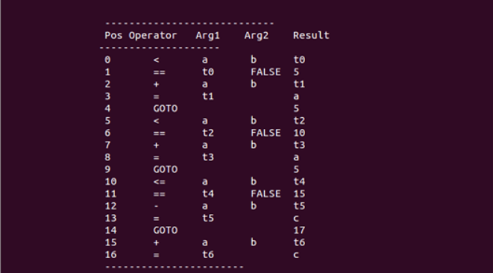
 | Experiment Title: Write a C program to generate machine code from abstract syntax tree generated by the parser. The instruction set specified in Note 2 may be considered as the target code.
 | Laboratory: Compiler Design LAB
Experiment No: 12 | Department: | Semester:

PROGRAM LOGIC:
- Read input string
- Consider each input string and convert in to machine code instructions.

PROGRAM
#include<stdio.h>
#include<stdlib.h>
#include<string.h>
int label[20];
int no=0;

int main() {
FILE *fp1, *fp2;
char fname[10], op[10], ch;
char operand1[8], operand2[8], result[8];
int i=0, j=0;

printf("\n Enter filename of the intermediate code");
scanf("%s", &fname);

fp1 = fopen(fname, "r");
fp2 = fopen("target.txt", "w");

if(fp1 == NULL || fp2 == NULL) {
printf("\n Error opening the file");
exit(0);
}

while(!feof(fp1)) {
fprintf(fp2, "\n");
fscanf(fp1, "%s", op);
i++;

if(check_label(i)) {
fprintf(fp2, "\nlabel#%d", i);
}

if(strcmp(op, "print") == 0) {
fscanf(fp1, "%s", result);
fprintf(fp2, "\n\t OUT %s", result);
}

if(strcmp(op, "goto") == 0) {
fscanf(fp1, "%s %s", operand1, operand2);
fprintf(fp2, "\n\t JMP %s,label#%s", operand1, operand2);
label[no++] = atoi(operand2);
}

if(strcmp(op, "[]=") == 0) {
fscanf(fp1, "%s %s %s", operand1, operand2, result);
fprintf(fp2, "\n\t STORE %s[%s],%s", operand1, operand2, result);
}
if(strcmp(op, "uminus") == 0) {
fscanf(fp1, "%s %s", operand1, result);
fprintf(fp2, "\n\t LOAD -%s,R1", operand1);
fprintf(fp2, "\n\t STORE R1,%s", result);
}

switch(op[0]) {
case '*':
fscanf(fp1, "%s %s %s", operand1, operand2, result);
fprintf(fp2, "\n \t LOAD", operand1);
fprintf(fp2, "\n \t LOAD %s,R1", operand2);
fprintf(fp2, "\n \t MUL R1,R0");
fprintf(fp2, "\n \t STORE R0,%s", result);
break;

case '+':
fscanf(fp1, "%s %s %s", operand1, operand2, result);
fprintf(fp2, "\n \t LOAD %s,R0", operand1);
fprintf(fp2, "\n \t LOAD %s,R1", operand2);
fprintf(fp2, "\n \t ADD R1,R0");
fprintf(fp2, "\n \t STORE R0,%s", result);
break;

case '-':
fscanf(fp1, "%s %s %s", operand1, operand2, result);
fprintf(fp2, "\n \t LOAD %s,R0", operand1);
fprintf(fp2, "\n \t LOAD %s,R1", operand2);
fprintf(fp2, "\n \t SUB R1,R0");
fprintf(fp2, "\n \t STORE R0,%s", result);
break;

case '/':
fscanf(fp1, "%s %s %s", operand1, operand2, result);
fprintf(fp2, "\n \t LOAD %s,R0", operand1);
fprintf(fp2, "\n \t LOAD %s,R1", operand2);
fprintf(fp2, "\n \t DIV R1,R0");
fprintf(fp2, "\n \t STORE R0,%s", result);
break;

case '%':
fscanf(fp1, "%s %s %s", operand1, operand2, result);
fprintf(fp2, "\n \t LOAD %s,R0", operand1);
fprintf(fp2, "\n \t LOAD %s,R1", operand2);
fprintf(fp2, "\n \t DIV R1,R0");
fprintf(fp2, "\n \t STORE R0,%s", result);
break;

case '=':
fscanf(fp1, "%s %s", operand1, result);
fprintf(fp2, "\n\t STORE %s %s", operand1, result);
break;
case '>':
j++;
fscanf(fp1, "%s %s %s", operand1, operand2, result);
fprintf(fp2, "\n \t LOAD %s,R0", operand1);
fprintf(fp2, "\n\t JGT %s,label#%s", operand2, result);
label[no++] = atoi(result);
break;

case '<':
fscanf(fp1, "%s %s %s", operand1, operand2, result);
fprintf(fp2, "\n \t LOAD %s,R0", operand1);
fprintf(fp2, "\n\t JLT %s,label#%d", operand2, result);
label[no++] = atoi(result);
break;
}
}

fclose(fp2);
fclose(fp1);
fp2 = fopen("target.txt", "r");
if(fp2 == NULL) {
printf("Error opening the file\n");
exit(0);
}
do {
ch = fgetc(fp2);
printf("%c", ch);
} while(ch != EOF);

fclose(fp1);
return 0;
}

int check_label(int k) {
int i;
for(i = 0; i < no; i++) {
if(k == label[i]) {
return 1;
}
}
return 0;
}

OUTPUT
